Course Name | ITD 2343 – Object Oriented Programming with C#
Instructor | Mark L. Pranger
Student Name | Lauren Lashley
Due date | January 11, 2026
Grade | <grade earned here>
Grading Comments | <instructor comments here>

Screenshots of File Explorer:
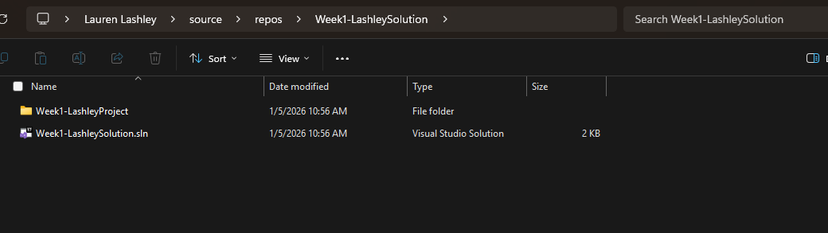
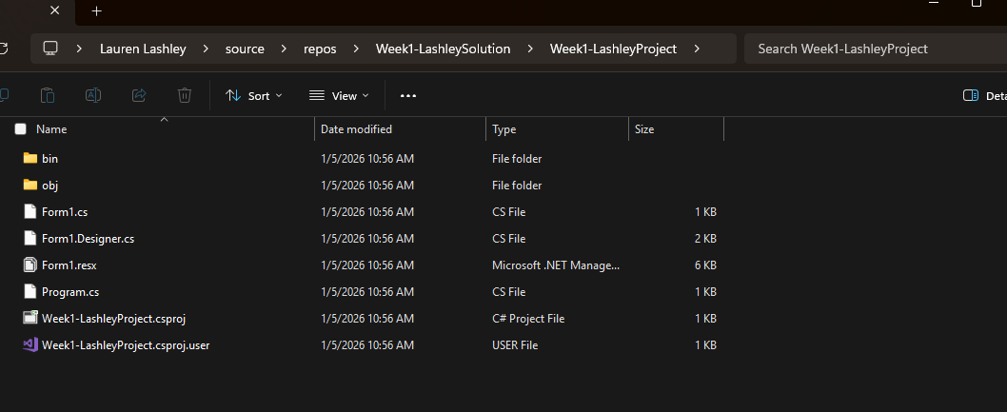
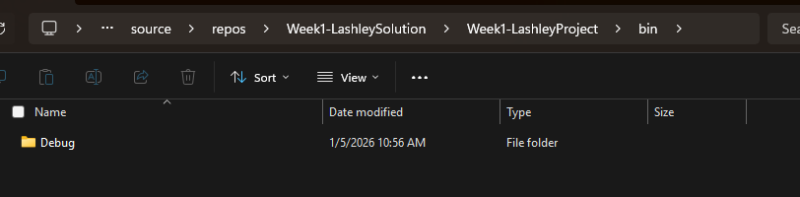
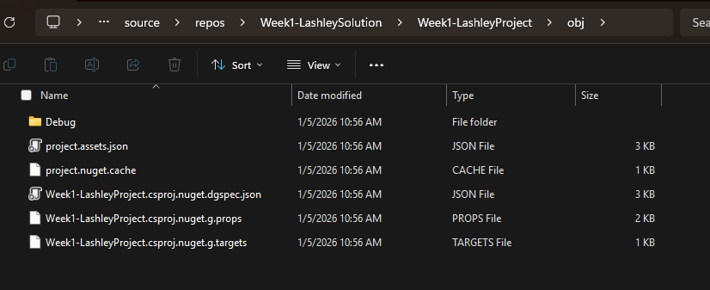

Screenshot Form Designer View:
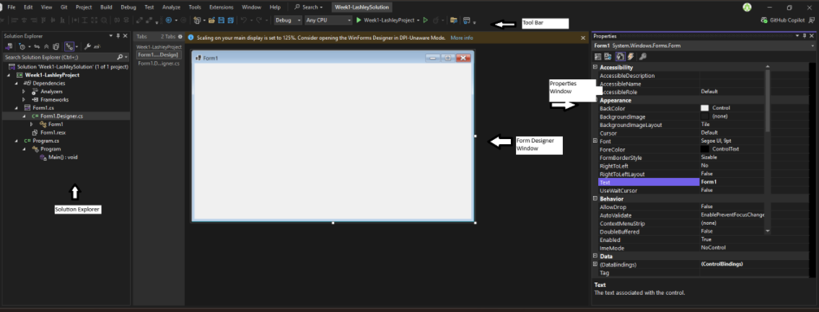

Screenshot Code View:
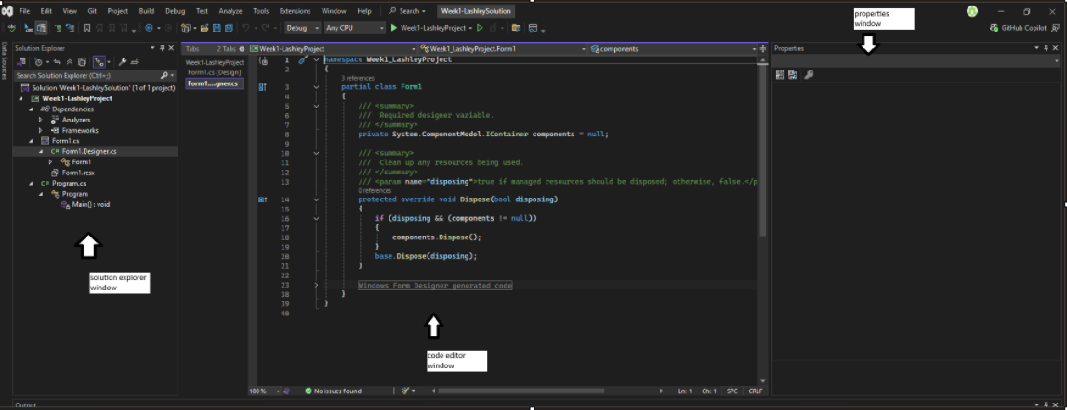

Last Screenshot:
